
Savitribai Phule Pune University
INTERDISCIPLINARY SCHOOL OF SCIENTIFIC COMPUTING
Mid Semester Examination – II October 2017
Course No. : SC – 104
Title : Mathematics for Scientific Computing
Date : 04/10/2017
Time : 1.5 hrs (2:00pm to 3:30pm) Marks : 30

Q.1 Evaluate the following integrals.

- (i) 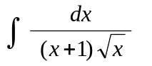 OR (ii) 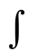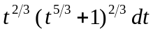 (2)
- (i) 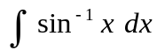 OR (ii) 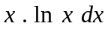 (2)
- (i) 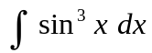 OR (ii) 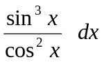 (2)
- (i)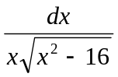 OR (ii) 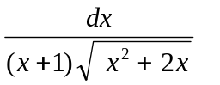 (2)

Q.2 Evaluate the following integrals.

- (i) 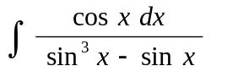 OR (ii) 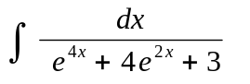 (3)

- (i) 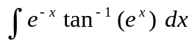 OR (ii) 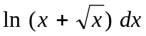 (3)
- Evaluate the integral 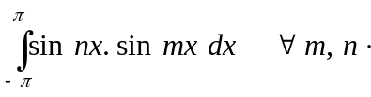 (2)

Q.3 (a) Determine the area enclosed by the curve (3)

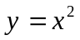 and the line 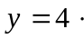

(b) Using integration show that the perimeter of circle of radius is 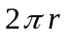units. (2)

- Find the volume of the right circular cone of radius and height using (3)
integration.

Q.4 (a) Find the perimeter of the curve (2)

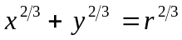
(Hint : Use the parametric form of the equation by taking 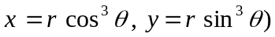

(b) Using integration determine the surface area of the sphere of radius 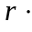 (3)

OR

Using integration determine the surface area of the curve given in part 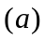 (4)
*****

